Comparing and Contrasting Eras
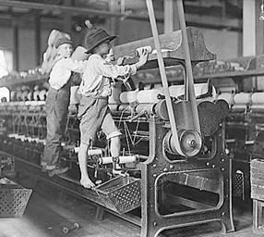
After reading excerpts from both Hard Times and Jane Eyre, we’ve seen how children were treated in both home and school. We have watched a few documentary short films on Child Labor in the Victorian era and have seen photos of how horrible children were treated as cheap labor. Now it’s time for you to reflect on how child labor has changed.
Write a 2-page essay on how CHILD LABOR is different today than it was in the Victorian era.

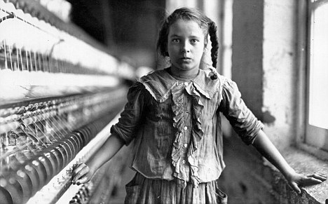
To get started, ask:
- What are the laws today on how old someone has to be to work an official job?
- How much do children under 18 years old make?
- How many hours are children allowed to work?
- What is the difference between an internship and a paid position?

You must use at least 2 sources of good reputation in your essay.
I am providing your sources so you can get used to citing correctly. We will examine how to judge sources in class.
It must be typed using TIMES NEW ROMAN 12 pt. font and be double-spaced.
Turn your essay in at TURNITIN.COM
DUE DATE: January 30th 2020

